Task 1: Practical skills investigation (20 marks) Weight 5%

Part A

DNA profiling of Humpback Whales

DNA profiling is a process that uses DNA to show relatedness or identity of individual humans, plants, or animals. It is used in forensics, anthropology, and conservation biology not only to determine the identity of individuals but also to determine relatedness. This process has been used to free innocent suspects, reunite children with their relatives, identify stolen animals, and prove that whale meat has been substituted for fish in sushi. It is used in times of war to help identify the remains of soldiers killed in combat. It is also being used to find genetic linkages to inherited diseases. In addition, scientists are learning a great deal about our evolutionary history from DNA analysis.

The Scenario:

For three years a team of researchers have been watching three different Humpback whale pods off the coast of Exmouth in Western Australia. They are especially interested in the genetic diversity of these whales. As the numbers of humpback whales are decreasing, determining the genetic diversity of these populations is increasingly more important. In particular, this team is interested in identifying the parents of one of the new baby whales, Kara. Through their observations of nursing behaviour they have matched Kara with her mother; however, none of their observations have helped them link Kara to her father. Today you are going to help them figure this out!

Humpback whale
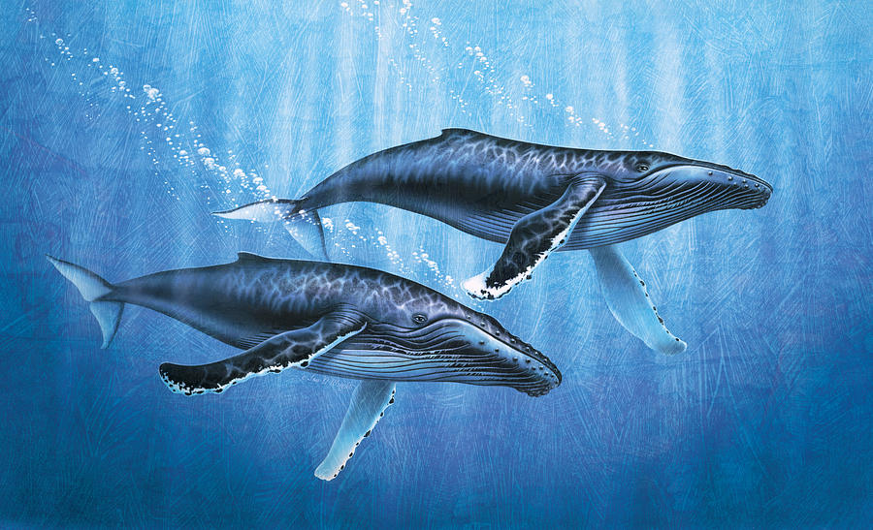

Materials:
You will need the following to perform Electrophoresis

    - BioEd Electrophoresis Tank(s)
    - Gel Casting Tray(s)
I
    - Gel Comb(s)
    - Yellow pipette tips
I
    - Micropipettes
    - BioEd Electrophoresis Power Supply
    - Agarose (DNA Grade if using DNA)
    - TBE (Tris-Borate-EDTA) Buffer (or equivalent)
    - DNA loading buffer (if using DNA)
    - DNA from Mother (1), Kara (2), and the two male whales (3 and 4)

Humpback Whale Pod Information:

Pod | Gender | DNA sample
1 | Female (mother) | 1
1 | Female (Kara) | 2
1 | Male A | 3
2 | Male B | 4

Procedure:
Follow the instructions provided by you teacher for setting up and using the gel electrophoresis equipment. (4 marks)

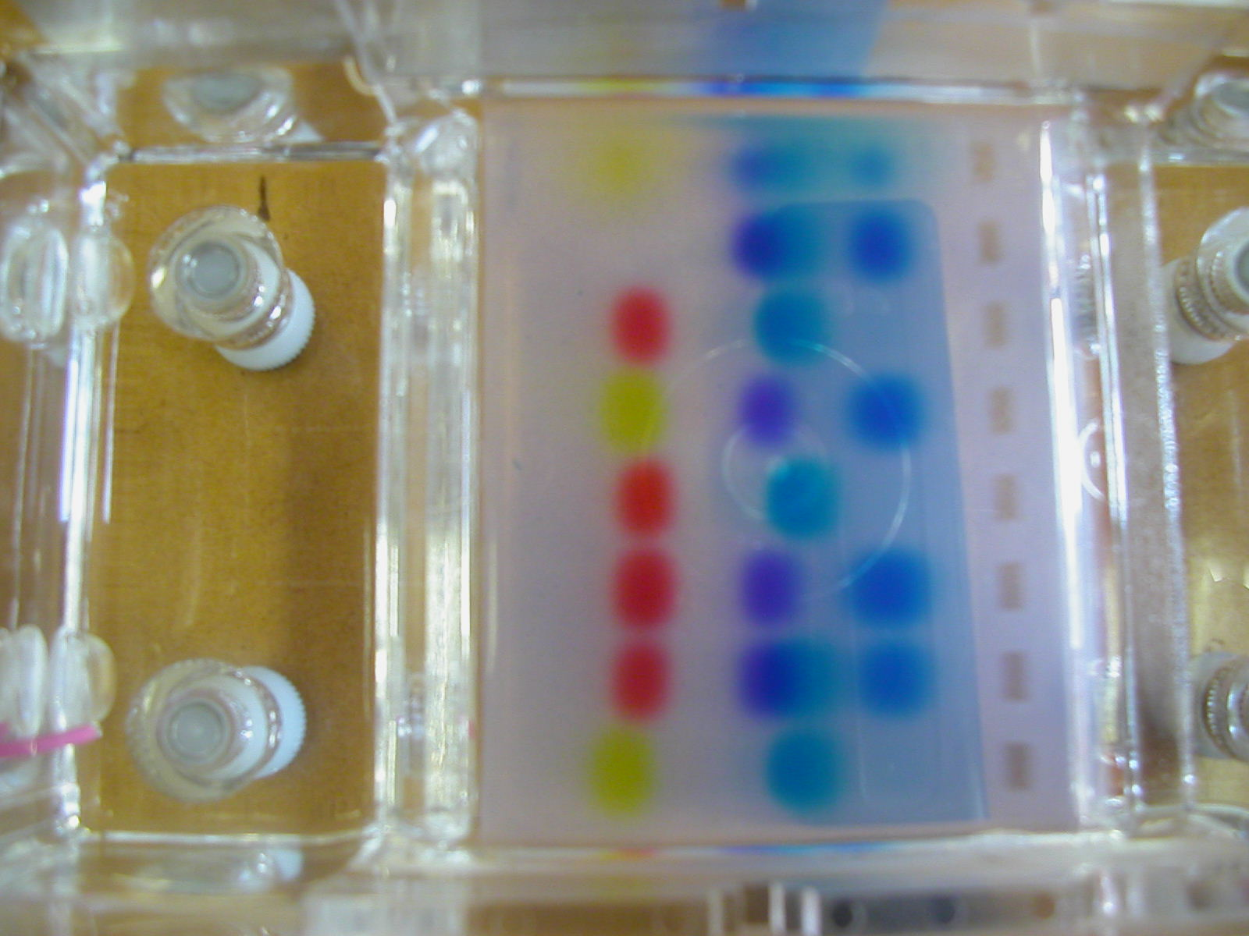
Photo courtesy of Julie Weber

- Collect a prepared, gel tray with set gel. The gel will appear opaque when fully set.
- Once set, you can carefully remove the gel comb. Wriggle the gel comb slowly to aid removal. It will feel a little tight to pull due to the vacuum created inside the well. If you move the gel slowly, air will leak around the gel comb teeth into the well. Rapid removal could cause the well to tear or collapse.
- Carefully remove the masking tape from the gel tray and always keeping the gel tray horizontal to the ground, position the gel tray and gel in the gel tank between the locating lugs
- BE SURE THAT THE GEL IS POSITIONED IN THE TANK WITH THE WELLS CLOSEST TO THE BLACK/NEGATIVE ELECTRODE.

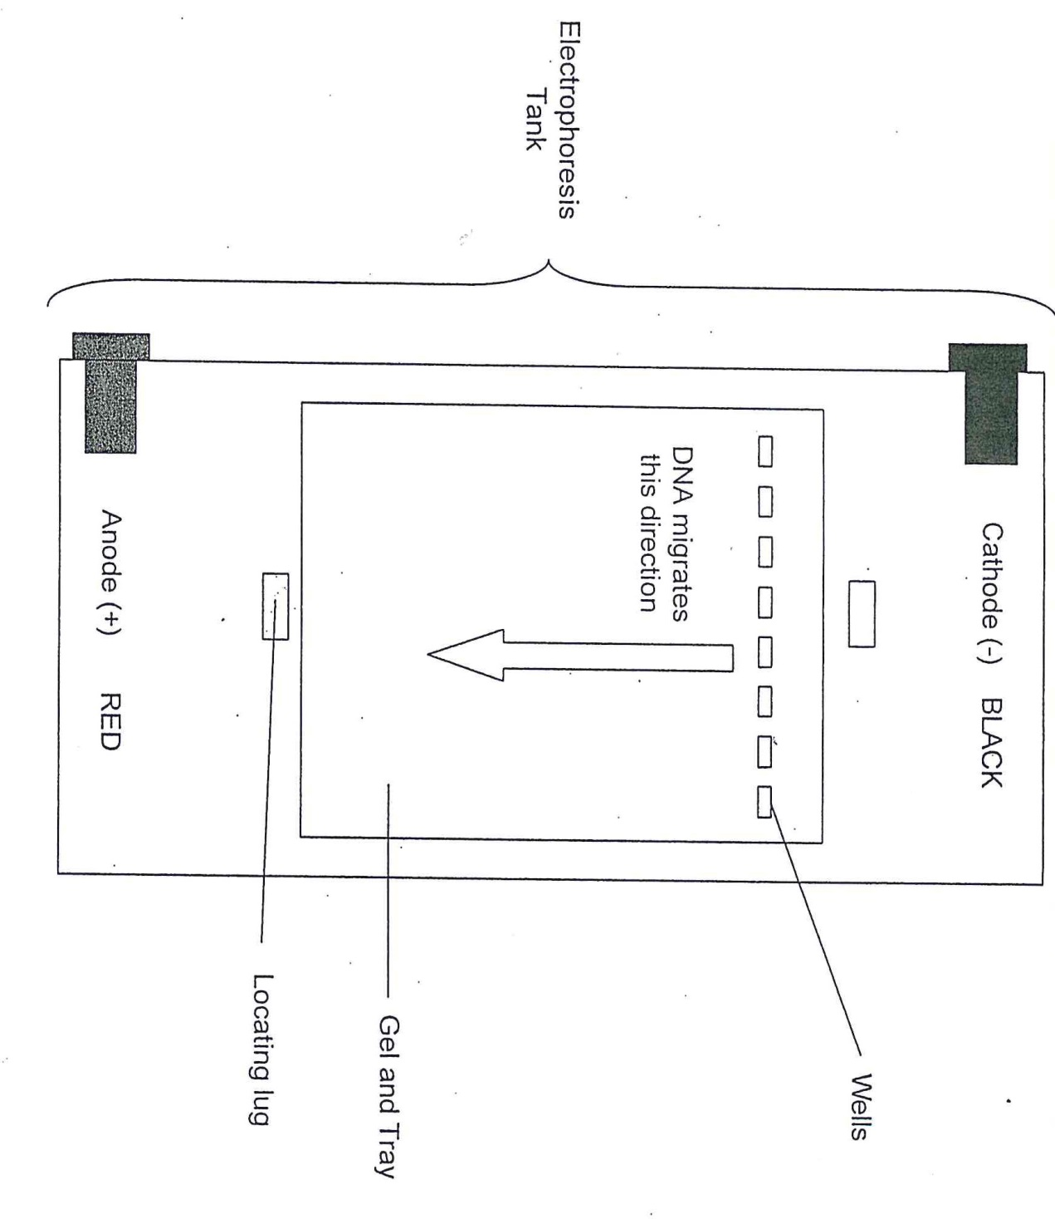
- Carefully fill the electrophoresis tank to about 2 or 3mm above the top surface of the agarose gel. This will ensure maximum efficiency of the electric field and keep run times to a minimum. ·
- Check to make sure there are no air bubbles in the well spaces.
- You can now fill the wells with your samples.(see below)
Hint: If you have less than 8 samples to run on a gel, fill the central wells in preference to the wells at the edges of the gel.

Using a Pipette

Place a yellow micropipette tip on the barrel of the pipette with gentle force to create a seal.
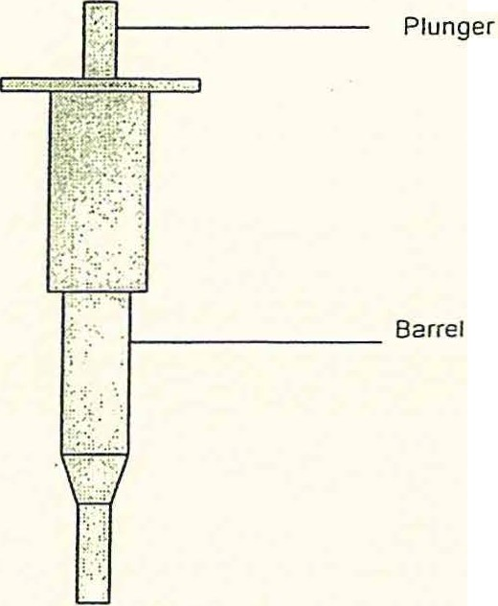

.. To aspirate a sample: depress the plunger fully, place micropipette into desired sample and in a slow, controlled motion, release the pressure on the plunger. The desired volume of sample should now be held inside the pipette tip.

To eject a sample : Place pipette tip above well/tube and in a slow and controlled motion, depress the plunger to completion. It is normal for a small trace of sample to stay in the pipette tip.

It is advisable to practice using a pipette before this investigation. Carefully load the sample into each well by steadily holding the tip of the micropipette over the well and slowly depressing the plunger on the pipette. Do not eject the sample too fast as the turbulence in the liquids will cause mixing of the sample with the buffer in the tank and your sample may be lost.

Hint: You can steady the tip of the pipette by resting the barrel of the pipette on a finger extended from your other hand.

- Draw a picture of your gel and label which samples are where before you turn on the power.
(1 mark)

4.

3.

2.

1.

Electrophoresis

You should now be ready to begin electrophoresis of your samples.

• Once the gel has been loaded, try not to move the gel tank as movement of the buffer within the tank can wash the samples out of the wells causing mixing between wells or worse, loss of sample.

• Place the lid on the electrophoresis box by sliding the lid along the grooves in the tank.
Be sure that the electrical plugs line up with the sockets on the tank.

., Never force a lid closed! Instead remove the lid a little and ensure that the electrical plugs line up with the sockets and try again.

• Once the unit is closed completely you can plug the electrophoresis tank into the power supply.

• Always check to be sure that you are inserting the RED cable into the RED socket on the power supply and the BLACK cable into the BLACK socket as well. This will ensure you never wire the electrophoresis tank backwards which will cause the samples to migrate in reverse and your samples will be lost!

• Choose a suitable voltage on the power supply that will suit your time needs.

The approximate run times below are based on a 0. 7% to 1% agarose gel.· Times will increase when using gels containing 1.5% and 2% agarose gels:

o 1OOV will give a run time of approximately 30 minutes to 1 hour depending on the ..·. size of the DNA fragments to be run and the amount of separation required.

o 1OV will be suitable for overnight applicatiOns.

o If you wish to run a gel for 3 hours, for example, you could choose a voltage somewhere between 25 and 40 volts.

• Turn the power supply on and the unit will now be under power.

NEVER remove the lid from the gel tank while the unit is still connected to the power supply!

• To ensure that the unit is receiving power, be sure to check for the presence of small bubbles forming on both electrodes. This occurs due to the splitting of H₂0 into hydrogen and oxygen gases.

- What does DNA stand for and what does it do?
(2 marks)

- What are some characteristics or properties of DNA?

(2marks)

One characteristic and one property

- Outline the steps/techniques used to obtain the DNA samples you are about to use (7marks)

Max 7 marks

- Outline how gel electrophoresis is used to obtain a DNA profile.
(4 marks)

Analyzing the DNA data

After the DNA has sufficiently separated turn off the power and carefully remove the gel. If you are colour -blind please ask for assistance.

- Draw a picture of your stained gel; be as accurate as possible in drawing the bands.
(2 marks)

4.

3.

2.

1.

Conclusion

- What can your data tell you about which whale is Kara's father? Explain
(3 marks)

You will sit a validation on the techniques and tools involved in this process. Marks -Practical 25% and Validation 75%.

